SIMATS ENGINEERING (SAVEETHA SCHOOL OF ENGINEERING)
Department of Computer Science and Engineering
CO1 ASSESSMENT TOOL 1 – Case Study Analysis
Course Code: | CSA10 / CSA1003 | Course Title: | Software Engineering
CO Assessed: | CO1 | Assessment: | Assessment Tool 1 – Case Study Analysis
Weightage: | 20% | Total Marks: | 25
CO1 Statement: | Apply advanced methodologies and agile project management techniques to manage software projects effectively
Student Name: | V. Deva chary | Reg. No.: | 192465041
Date: | 22/07/2026 | Duration: | 60 minutes

Code of Conduct
I V. Deva chary (192465041) certify that this submission is my original work and that I have adhered to the guidelines specified for this assessment. I understand that any violation of academic integrity rules will result in disciplinary action.
Signature of the Student: V. Deva chary

Travel Expense Tracking and Budget Management Application
- Understand the Problem Statement
  - Explain the problem in your own words.
Nowadays, in this generation tour/trips are common. If there is a holidays for weak, then we plan for the trip. We plan the trip with some amount of budget but sometimes or most of the times, the budget will get exceeds with budget we carry. We need a budget tracking and management system to enjoy the travel. System that tracks the expenses of travel and manage the budget for the trip and inform us to the budget and way of their expenses basis of the food, travel, room, etc.
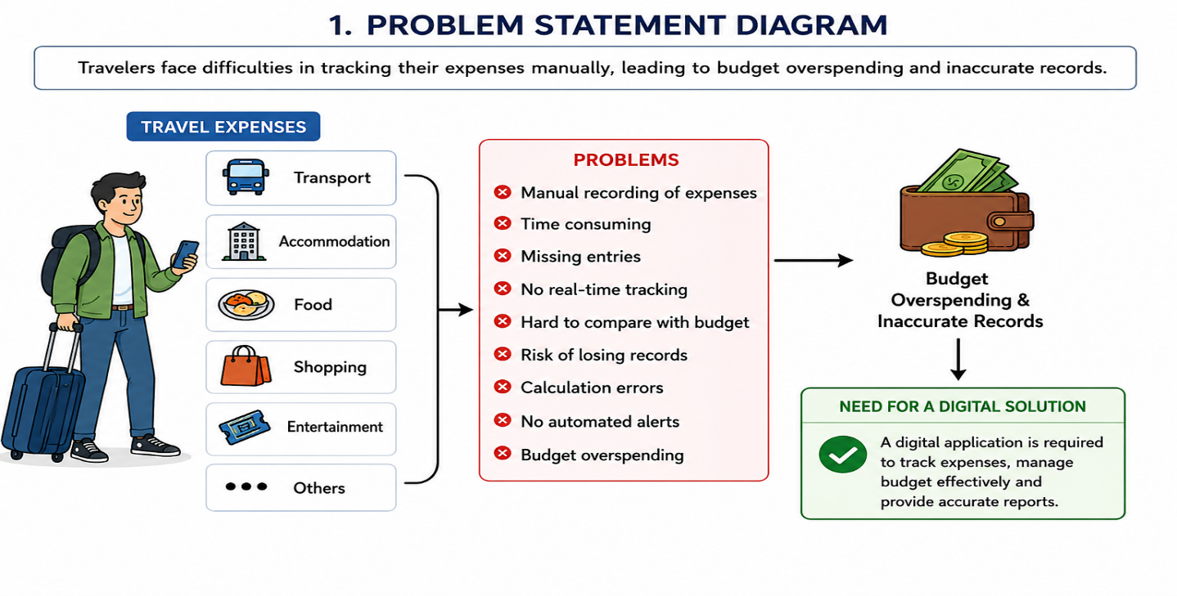
  - Identify the objectives of the proposed system.
  - To simplify travel expense management for travelers.
  - To enable users to create and manage travel budgets before their trips.
  - To provide a platform for recording travel expenses quickly and accurately.
  - To categorize expenses into transportation, accommodation, food, shopping, entertainment, and other categories.
  - To automatically calculate the total amount spent during a trip.
  - To display the remaining budget in real time.
  - To compare planned budgets with actual expenses.
  - To notify users when they approach or exceed their budget limits.
  - To generate detailed expense reports and financial summaries.
  - To help users analyze their spending habits and identify areas for saving.
  - To reduce manual calculations and minimize recording errors.
  - To securely store travel expense records for future reference.
  - To provide a simple, user-friendly, and easy-to-use interface.
  - To support better financial planning through accurate and timely information.
  - To improve decision-making, financial discipline, and budget control during travel.
- State the scope of the problem.
- The project focuses on developing a Travel Expense Tracking and Budget Management Application to help users manage travel-related expenses efficiently.
- It allows users to create and manage budgets for different trips.
- The system records expenses related to transportation, accommodation, food, shopping, entertainment, and other travel activities.
- Users can add, edit, delete, and view their expense records at any time.
- The application automatically calculates total expenses and displays the remaining budget.
- It provides real-time notifications when users approach or exceed their budget limits.
- The system generates detailed reports and expense summaries for better financial analysis.
- Expense data is securely stored and can be accessed through web or mobile platforms.
- The application supports individual travelers, families, students, and business professionals.
- It ensures secure user authentication and protects financial data.
- The project aims to improve financial planning, reduce overspending, and simplify expense management during travel.
- The application is limited to expense tracking and budget management only.
- It does not include travel ticket booking, hotel reservations, or route navigation services.
- The system is designed to be scalable and can be enhanced with features such as bank integration, digital payment support, and multi-currency management in future versions.
- The overall scope is to provide a secure, user-friendly, and efficient solution for managing travel expenses and maintaining budget control.
- Identify Key Stakeholders and Challenges
  - Identify all the stakeholders involved in the system.
The Travel Expense Tracking and Budget Management Application involves several important stakeholders who contribute to its successful operation. The primary stakeholders are travellers who use this application. Administrators manage the system and user accounts. Financial analysts may use reports for expense analysis. Developers maintain and update the application. Payment service providers may support secure online transactions. Cloud service providers offer reliable storage and synchronization of user data across multiple devices.
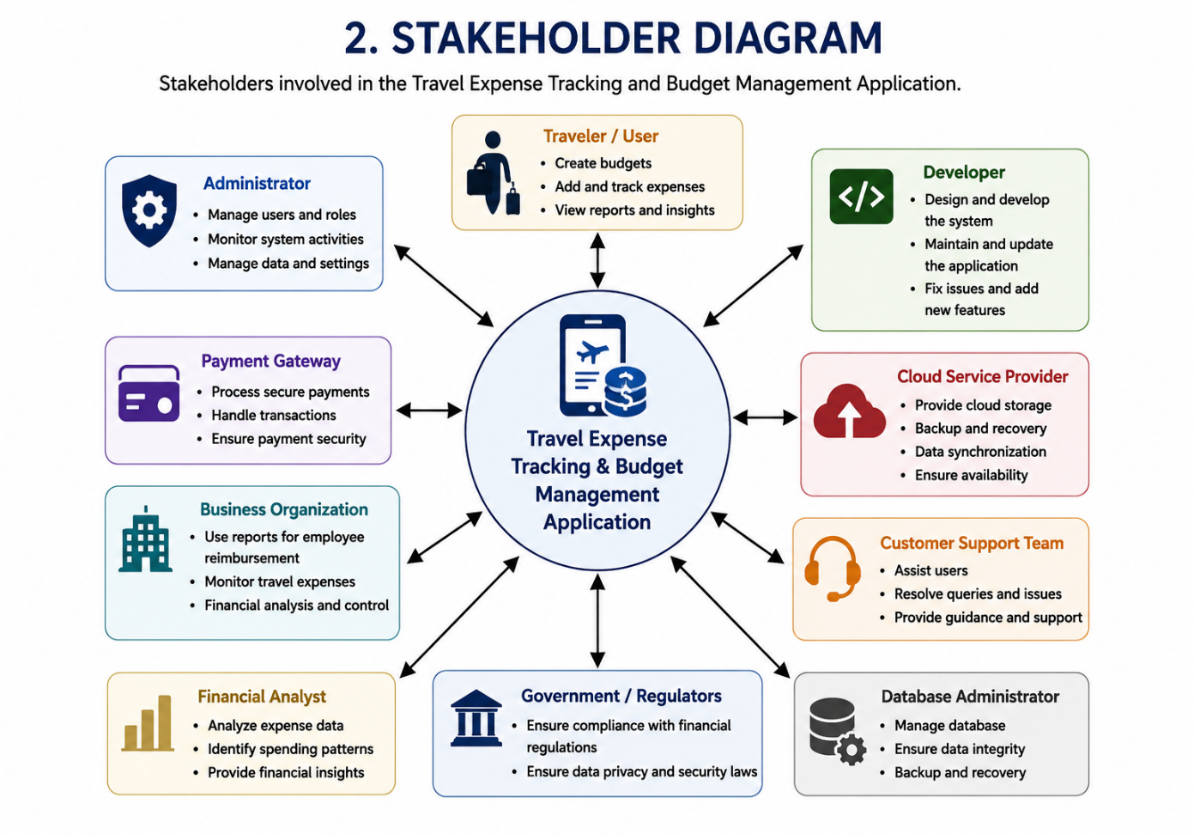
  - Explain the roles and responsibilities of each stakeholder.

Traveler / User

Creates travel budgets, records daily expenses, and monitors spending throughout the trip. Reviews reports and ensures expense details are entered accurately.

Administrator

Manages user accounts, system settings, and monitors the application's overall performance. Ensures secure system operation and maintains user data.

Software Developer

Designs, develops, updates, and maintains the application. Fixes software bugs and implements new features to improve system performance.

Project Manager

Plans and manages the software development process, allocates tasks, and monitors project progress. Coordinates communication among team members to ensure timely project completion.

Test Engineer

Tests the application to identify functional and security issues before deployment. Verifies that all defects are resolved and the system meets quality standards.

Database Administrator (DBA)

Maintains the database, secures user information, and performs regular backups. Ensures data integrity and supports efficient database performance.

Payment Service Provider

Processes secure online transactions and protects users from payment fraud. Ensures safe and reliable payment processing using secure payment gateways.

Cloud Service Provider

Provides cloud storage, data synchronization, and backup services. Ensures that user data is always available, secure, and accessible across multiple devices.

Government Authorities / Regulatory Bodies

Establish regulations related to financial reporting, data privacy, and cybersecurity. Ensure that the application complies with all legal and security requirements.

Business Organization

Uses the application to monitor employee travel expenses and process reimbursements. Reviews expense reports and helps manage travel budgets efficiently.
  - Discuss the major challenges and issues faced by the stakeholders.
- Travelers / Users: Forgetting to record expenses and maintaining accurate financial records.
- Administrators: Ensuring continuous system availability and protecting user data.
- Software Developers: Designing a secure, scalable, and user-friendly application.
- Test Engineers: Identifying software defects and security vulnerabilities before deployment.
- Database Administrators: Maintaining database performance and preventing data loss.
- Payment Service Providers: Ensuring secure payment processing and preventing fraudulent transactions.
- Cloud Service Providers: Providing continuous service availability and secure data synchronization.
- Customer Support Team: Resolving user issues and providing timely technical assistance.
- Business Organizations: Managing accurate expense reports and simplifying reimbursement processes.
- Analyze the Current Approach
  - Describe the existing system or current process.
At present, many travellers manage their travel expenses using traditional methods such as notebooks, paper receipts, calculators, or spreadsheet applications like Microsoft Excel. During a trip, they manually record every expense related to transportation, accommodation, food, shopping, and entertainment. These methods are time-consuming and error-prone. Expense summaries are not generated automatically. Budget monitoring becomes difficult during long trips. As a result, travelers struggle to control their expenses and make informed financial decisions during their trips. Therefore, the current process lacks automation, accuracy, convenience, and effective budget management.
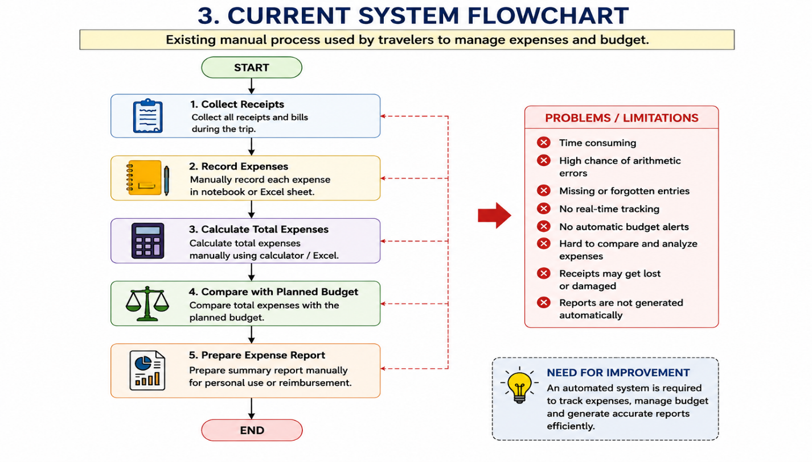

  - Identify its strengths and limitations.
Strengths
- Users only need a notebook, calculator, or spreadsheet to record their travel expenses.
- The system can be used without an internet connection, making it suitable for remote locations.
- Maintaining manual records does not require expensive software or additional infrastructure.
- Users have complete control over how they organize and maintain their financial information.
- No technical knowledge or training is required to begin using the manual system.
Limitations
    - Manual entry of expenses takes considerable time and effort.
    - Users may make calculation mistakes while totaling expenses and analyzing budgets.
    - Travelers may forget to record expenses immediately, resulting in missing entries.
    - The system cannot notify users when they exceed their planned budget.
    - Expense reports and summaries must be prepared manually, which is inefficient.
    - Searching, updating, and maintaining records becomes difficult as data grows.
    - Notebooks, receipts, or spreadsheet files can be lost, damaged, or accidentally deleted.
    - Users cannot monitor their spending instantly during the trip.
    - The system does not provide charts, graphs, or spending insights for better financial planning.
  - Analyze the problems or gaps that need to be addressed.
- Manual Data Entry: The current system relies on manual recording of expenses, which increases the chances of human errors and inaccurate records.
- Incomplete Expense Records: Travelers may forget to record small or daily expenses, resulting in incomplete financial information.
- No Automated Calculations: The system does not automatically calculate total expenses, making budget monitoring difficult and increasing the risk of overspending.
- Lack of Budget Alerts: There are no real-time notifications or warnings when users approach or exceed their planned budget.
- Manual Report Generation: Expense reports must be prepared manually, which is time-consuming and delays financial analysis.
- No Visual Analysis: The existing system does not provide charts, graphs, or dashboards to help users understand their spending patterns.
- Risk of Data Loss: Expense records stored in notebooks or spreadsheets can be lost, damaged, or accidentally deleted.
- No Secure Backup: The current approach does not provide cloud storage or automatic backup for important financial data.
- Difficulty in Searching Records: Finding previous travel expense records becomes difficult as the amount of data increases.
- No Automatic Expense Categorization: Users must manually organize expenses into categories, reducing efficiency.
- Limited Financial Insights: The system cannot analyze spending habits or provide recommendations for better financial planning.
- Reimbursement Challenges: Business travelers face difficulties preparing reimbursement reports because manual records may contain errors or missing information.
- Poor Data Accessibility: Expense records cannot be accessed easily from multiple devices or locations.
- Lack of Security: Manual systems provide limited protection for sensitive financial information.
- Need for an Automated Solution: An efficient software-based system is required to improve accuracy, security, reporting, and overall travel expense management.
- Propose a Suitable Solution Using Software Engineering Principles

- Propose a Suitable Solution Using Software Engineering Principles
  - Design a software-based solution for the given problem.
The proposed solution is a Travel Expense Tracking and Budget Management Application. Users can create trips and set spending limits. Expenses are recorded under different categories. The application displays remaining budget and spending statistics. Reports and charts help users analyze their expenses. Users can edit or delete incorrect entries whenever necessary to maintain accurate records. The application generates detailed reports and charts that help users understand their spending patterns. Cloud storage ensures that expense records remain safe and accessible from multiple devices.
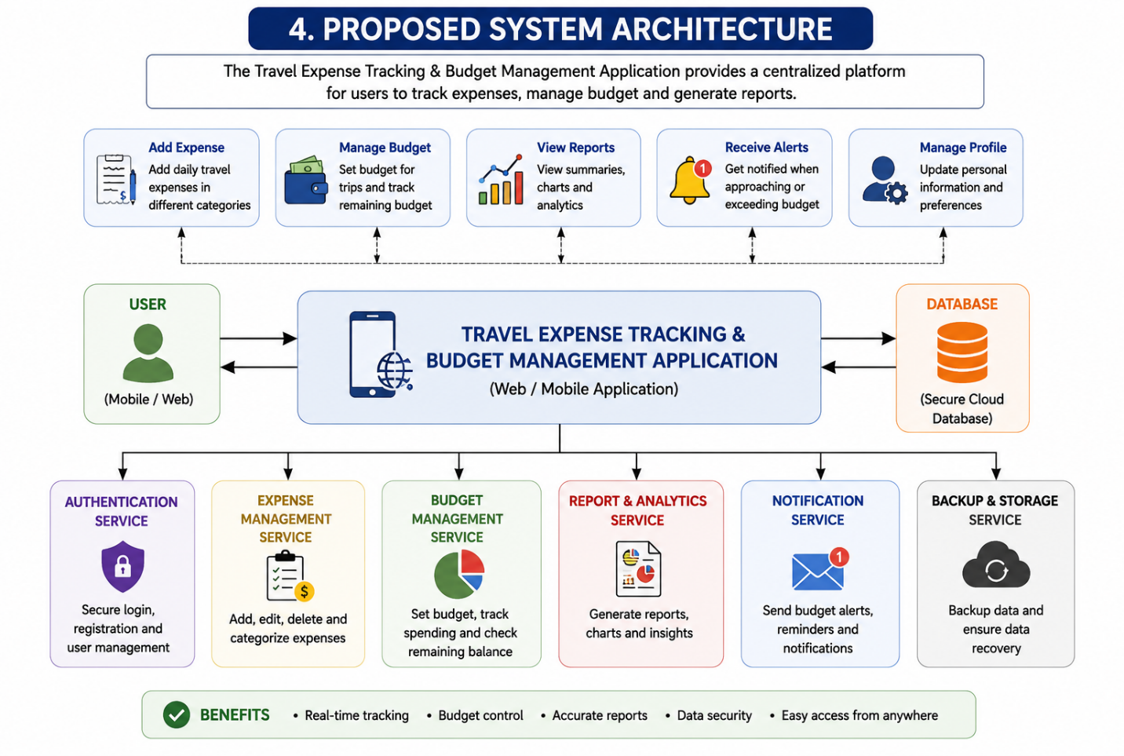
  - Describe the major functional modules of the proposed system.
- User Authentication Module: Enables user registration, secure login, and profile management.
- Trip and Budget Management Module: Allows users to create trips, set budgets, and manage travel plans.
- Expense Management Module: Records, edits, deletes, and categorizes travel expenses.
- Budget Monitoring Module: Tracks spending and compares actual expenses with the planned budget.
- Notification and Alert Module: Sends alerts when users approach or exceed their budget limits.
- Reports and Analytics Module: Generates expense reports, summaries, charts, and spending analysis.
- Data Storage Module: Securely stores travel and expense data for future reference.
- Security Module: Protects user information through authentication, encryption, and secure access.
- Admin Module: Manages users, monitors system performance, and handles system maintenance.
- Backup and Recovery Module: Performs regular backups and restores data when required.
  - Identify the functional and non-functional requirements.
The proposed Travel Expense Tracking and Budget Management Application requires both functional and non-functional requirements to ensure its successful operation. Functional requirements include user registration, secure login, password management, and profile updates. The system must allow users to create trips, define travel budgets, and record expenses under different categories. Users should be able to edit, delete, search, and view expense records whenever required. The application must automatically calculate total expenses and display the remaining budget in real time.
- Explain how software engineering principles such as modularity, scalability, maintainability, reliability, usability, and security are incorporated into your solution.
The proposed Travel Expense Tracking and Budget Management Application follows important software engineering principles to ensure high quality and long-term success. Modularity is achieved by dividing the application into separate modules such as User Management, Expense Tracking, Budget Management, Reporting, and Notifications. This modular structure allows developers to update or modify individual modules without affecting the entire system. Scalability enables the application to support thousands of users and increasing amounts of expense data as the system grows. Maintainability is ensured by using clean coding practices, proper documentation, and organized software architecture, making future enhancements easier. Reliability is achieved through accurate expense calculations, automatic data validation, and regular database backups to prevent data loss
- Justify the Chosen Methodology/Framework
  - Select an appropriate Software Development Life Cycle (SDLC) model or software development framework (e.g., Agile, Scrum, Waterfall, Spiral, DevOps).
The Agile Software Development Life Cycle (SDLC) model is the most suitable methodology for developing the Travel Expense Tracking and Budget Management Application. Agile focuses on developing software in small, manageable iterations called sprints, allowing the team to deliver working features quickly. Since user requirements may change during development, Agile provides the flexibility to modify features without affecting the entire project. The application includes several independent modules, such as user management, budget management, expense tracking, report generation, and notifications, which can be developed incrementally. Agile encourages continuous communication between developers, testers, and stakeholders throughout the project. Regular feedback from users helps improve the application's functionality and user experience.
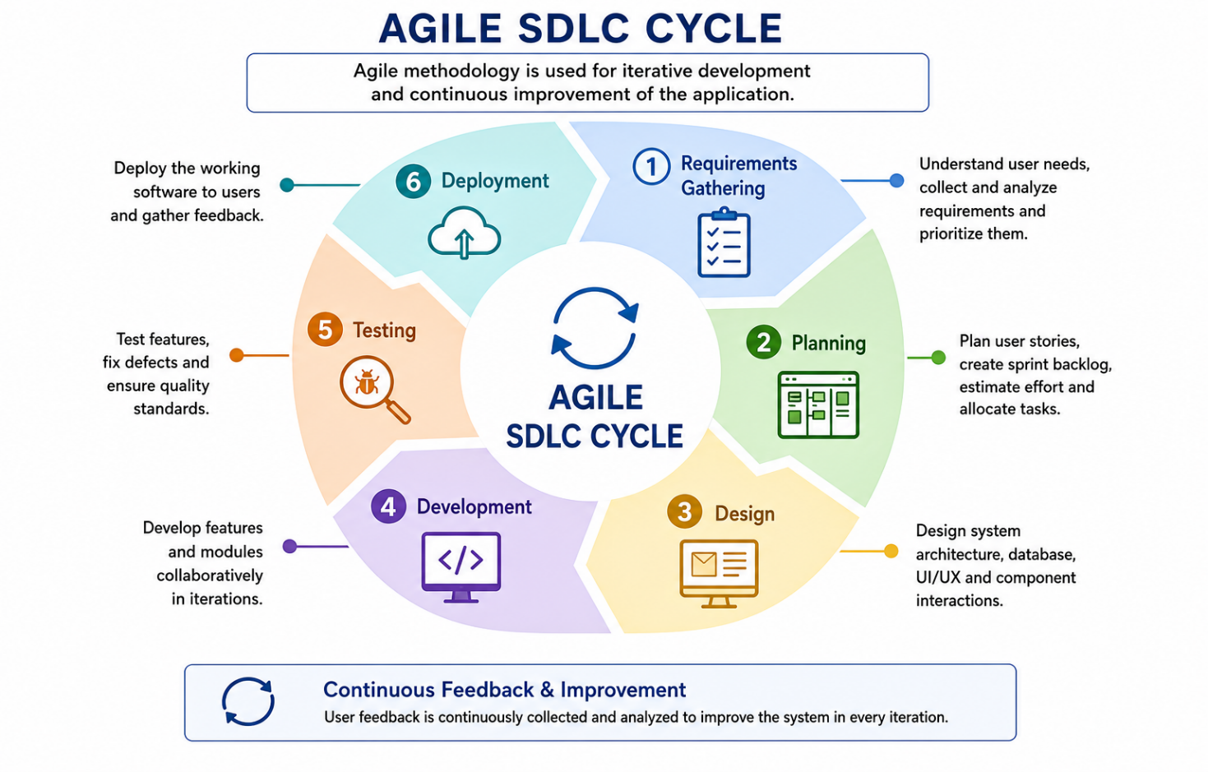

  - Justify why the selected methodology/framework is suitable for the proposed system.
Agile is highly suitable for the Travel Expense Tracking and Budget Management Application because it supports flexibility and continuous improvement throughout the software development process. User requirements for travel applications often change as new features and technologies become available. Agile allows developers to modify system requirements without restarting the entire project. The application contains multiple functional modules that can be developed and tested independently during different sprints. Frequent interaction with stakeholders ensures that the developed features meet user expectations. Continuous testing reduces software defects and improves overall system reliability. Developers receive immediate feedback from users, enabling them to make quick improvements.
- Explain how it supports successful project development and maintenance.
The Agile methodology supports successful project development by dividing the project into smaller and manageable development cycles called sprints. Each sprint focuses on delivering a specific set of features, making project management more organized and efficient. Continuous communication among developers, testers, project managers, and stakeholders ensures that everyone clearly understands the project objectives. Frequent software testing during each sprint helps identify and resolve defects before they become major issues. Regular feedback from users allows developers to improve the application according to actual user needs. Agile encourages continuous integration, ensuring that newly developed features work correctly with existing modules.
- Discuss Expected Outcomes and Limitations
  - Describe the expected benefits of the proposed solution.
  - Simplifies the process of managing travel expenses.
  - Enables users to record expenses quickly and accurately during trips.
  - Automatically calculates total expenses and compares them with the planned budget.
  - Provides real-time budget monitoring to help users track their spending.
  - Sends notifications when users approach or exceed their budget limits.
  - Categorizes expenses into transportation, accommodation, food, shopping, entertainment, and other categories for better organization.
  - Generates detailed reports and graphical summaries for easy expense analysis.
  - Helps users understand their spending patterns and improve financial planning.
  - Assists business travellers in preparing reimbursement claims efficiently.
  - Stores expense records securely using cloud storage.
  - Allows users to access their expense data from multiple devices.
  - Reduces manual calculations, saving time and minimizing human errors.
  - Protects sensitive financial information through secure authentication and data encryption.
  - Improves overall accuracy, convenience, and efficiency in travel expense management.
  - Helps users make informed financial decisions and stay within their planned travel budget.
  - Explain how the solution addresses the identified challenges.
The proposed application effectively addresses the challenges identified in the existing travel expense management process. It replaces manual record-keeping with a digital system that allows users to enter expenses instantly during their trips. Automatic calculations eliminate human errors that commonly occur during manual budgeting. Real-time budget monitoring helps users understand how much money has been spent and how much budget remains. Budget alerts notify users before they exceed their planned spending limits, helping them avoid unnecessary expenses. The application categorizes expenses automatically, making financial records well organized and easier to understand.
- Discuss potential risks, implementation challenges, and limitations.

Potential Risks
The application stores sensitive financial information, making it vulnerable to cyberattacks, data breaches, and unauthorized access if proper security measures are not implemented. Software bugs, server failures, or data loss may also affect system reliability and reduce user trust. Regular security updates, encryption, and data backup are essential to minimize these risks.

Implementation Challenges
Developing the application requires skilled software developers, extensive testing, and cloud infrastructure, which can increase development time and cost. Integrating payment gateways, cloud services, and ensuring compatibility across different devices and operating systems adds technical complexity. Maintaining high performance while supporting a growing number of users is another significant challenge.

Limitations
The application depends on a stable internet connection for cloud synchronization, which may not always be available during travel. Users who forget to record expenses regularly may still have incomplete financial records despite the application's features. Additionally, users who are not familiar with digital applications may require training or guidance to use the system effectively.
  - Suggest possible future enhancements.
The Travel Expense Tracking and Budget Management Application can be improved further by adding several advanced features in future versions. Artificial Intelligence can be integrated to analyze users' spending habits and provide personalized budgeting recommendations. Machine learning algorithms can predict future travel expenses based on previous spending patterns. Multi-currency support can be added to help international travellers manage expenses in different countries more conveniently. Integration with banking services, credit cards, and digital wallets can automate expense recording and reduce manual data entry
Rubrics for Calculation
Criteria | Excellent (5 Marks) | Good (3 Marks) | Satisfactory (2 Marks) | Needs Improvement (1 Mark)
Problem Understanding | Clearly explains the problem, objectives, and scope with complete understanding. | Explains the problem with minor omissions. | Basic understanding with limited explanation. | Poor understanding; objectives and scope are unclear or missing.
Stakeholder & Challenge Analysis | Identifies all stakeholders, their roles, and challenges with clear analysis. | Identifies most stakeholders and challenges with adequate analysis. | Identifies only a few stakeholders or challenges. | Stakeholders and system analysis are incomplete or inaccurate.
Current System Analysis | Thoroughly analyzes the existing system, strengths, weaknesses, and identifies all gaps. | Good analysis with most strengths and weaknesses identified. | Limited analysis with partial identification of issues. | Proposed solution is unclear or inappropriate; requirements are largely missing.
Proposed Software Solution & Software Engineering Principles | Proposes an innovative, feasible solution applying appropriate software engineering principles (modularity, scalability, maintainability, security, etc.). | Suitable solution with good application of software engineering principles. | Basic solution with limited application of software engineering principles. | Methodology is inappropriate, poorly justified, or not discussed.
Methodology/ Framework Justification | Selects the most suitable SDLC/model/framework and provides strong technical justification. | Suitable methodology selected with adequate justification. | Methodology selected but justification is weak. | Outcomes, limitations, or future enhancements are missing; report lacks organization and clarity.

Criteria | Mark
Problem Understanding | /5
Stakeholder & Challenge Analysis | /5
Current System Analysis | /5
Proposed Software Solution & Software Engineering Principles | /5
Methodology/ Framework Justification | /5
TOTAL | /5

